**Test log**

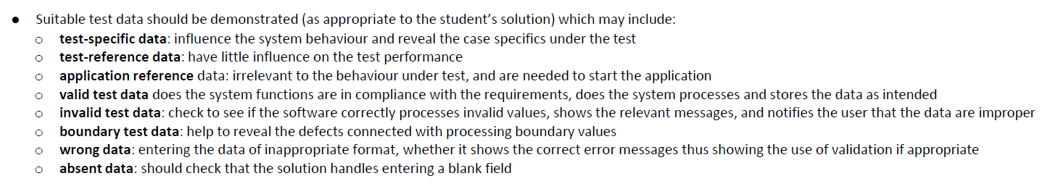

|  |  |  |  |
| --- | --- | --- | --- |
| **Main window** |  |  |  |
| **Description of Test** | **Test Data** | **Outcome** | **Notes** |
| Absent data |  | Message box saying “Login unsuccessful” | Functions as intended |
| Wrong data |  |  | No “wrong” data to test |
| Boundary test data |  |  | No boundary to test |
| Invalid test data | “UserID;”, “'Password'” | Message box saying “Please only include valid characters” | Functions as intended |
| Valid test data | 7, 7 | Message box saying “Login successful” | Functions as intended |
| Application reference | 7, 7 | Message box saying “Login successful” | Functions as intended |

|  |  |  |  |
| --- | --- | --- | --- |
| **Register window** |  |  |  |
| **Description of Test** | **Test Data** | **Outcome** | **Notes** |
| Absent data |  | Message box saying “Please enter something for each box | Functions as intended |
| Wrong data |  |  | No “wrong” data to test |
| Boundary test data |  |  | No boundary to test |
| Invalid test data | test Password, tester”FName, tester LName, [test@Email;com](mailto:test@Email.com) | Message box saying “Please only include valid characters” | Functions as intended |
| Valid test data | testPassword, testerFName, testerLName, [test@Email.com](mailto:test@Email.com) | Message box saying “Registration successful” | Functions as intended |
| Application reference | testPassword, testerFName, testerLName, [test@Email.com](mailto:test@Email.com) | Message box saying “Registration successful” | Functions as intended |

|  |  |  |  |
| --- | --- | --- | --- |
| **Reset password** |  |  |  |
| **Description of Test** | **Test Data** | **Outcome** | **Notes** |
| Absent data |  | Message box saying “Please enter something for each box | Functions as intended |
| Wrong data |  |  | No “wrong” data to test |
| Boundary test data |  |  | No boundary to test |
| Invalid test data | 7, newTestPassword, newPassword | Message box saying “Password must match” | Functions as intended |
| Valid test data | 7, newPassword, newPassword | Message box saying “Change successful” | Functions as intended |
| Application reference | 7, newPassword, newPassword | Message box saying “Change successful” | Functions as intended |